**IMPLEMENTATION OF GENERIC PROGRAMMING**

**AIM:**

Write a java program to implement Generic Programming.

**PROGRAM**:

/**

*

* @author 2162014

*/

import java.util.ArrayList;

import java.util.NoSuchElementException;

public class Stack<T> {

private ArrayList<T> items;

public Stack() {

items = new ArrayList<>();

}

public void push(T item) {

items.add(item);

}

public T pop() {

if (isEmpty()) {

throw new NoSuchElementException("Stack is empty");

}

return items.remove(items.size() - 1);

}

public T peek() {

if (isEmpty()) {

throw new NoSuchElementException("Stack is empty");

}

return items.get(items.size() - 1);

}

public boolean isEmpty() {

return items.isEmpty();

}

public int size() {

return items.size();

}

public static void main(String[] args) {

Stack<Integer> intStack = new Stack<>();

intStack.push(61);

intStack.push(87);

intStack.push(32);

System.out.println("Top element: " + intStack.peek());

System.out.println("Size of stack: " + intStack.size());

while (!intStack.isEmpty()) {

System.out.println(intStack.pop());

}

}

}

**OUTPUTS**:

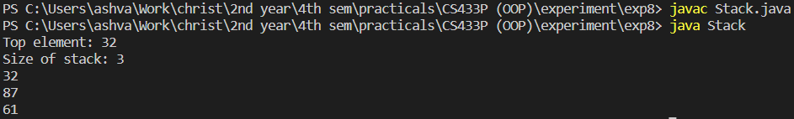

**RESULTS:**

The java program was created successfully implements Generic Programming.